

SOUTHDALE ELC ACTION PLAN
TO SUPPORT THE DELIVERY OF SIP

2026 / 2027


ELC Vision and Values & ELC Curriculum Rationale
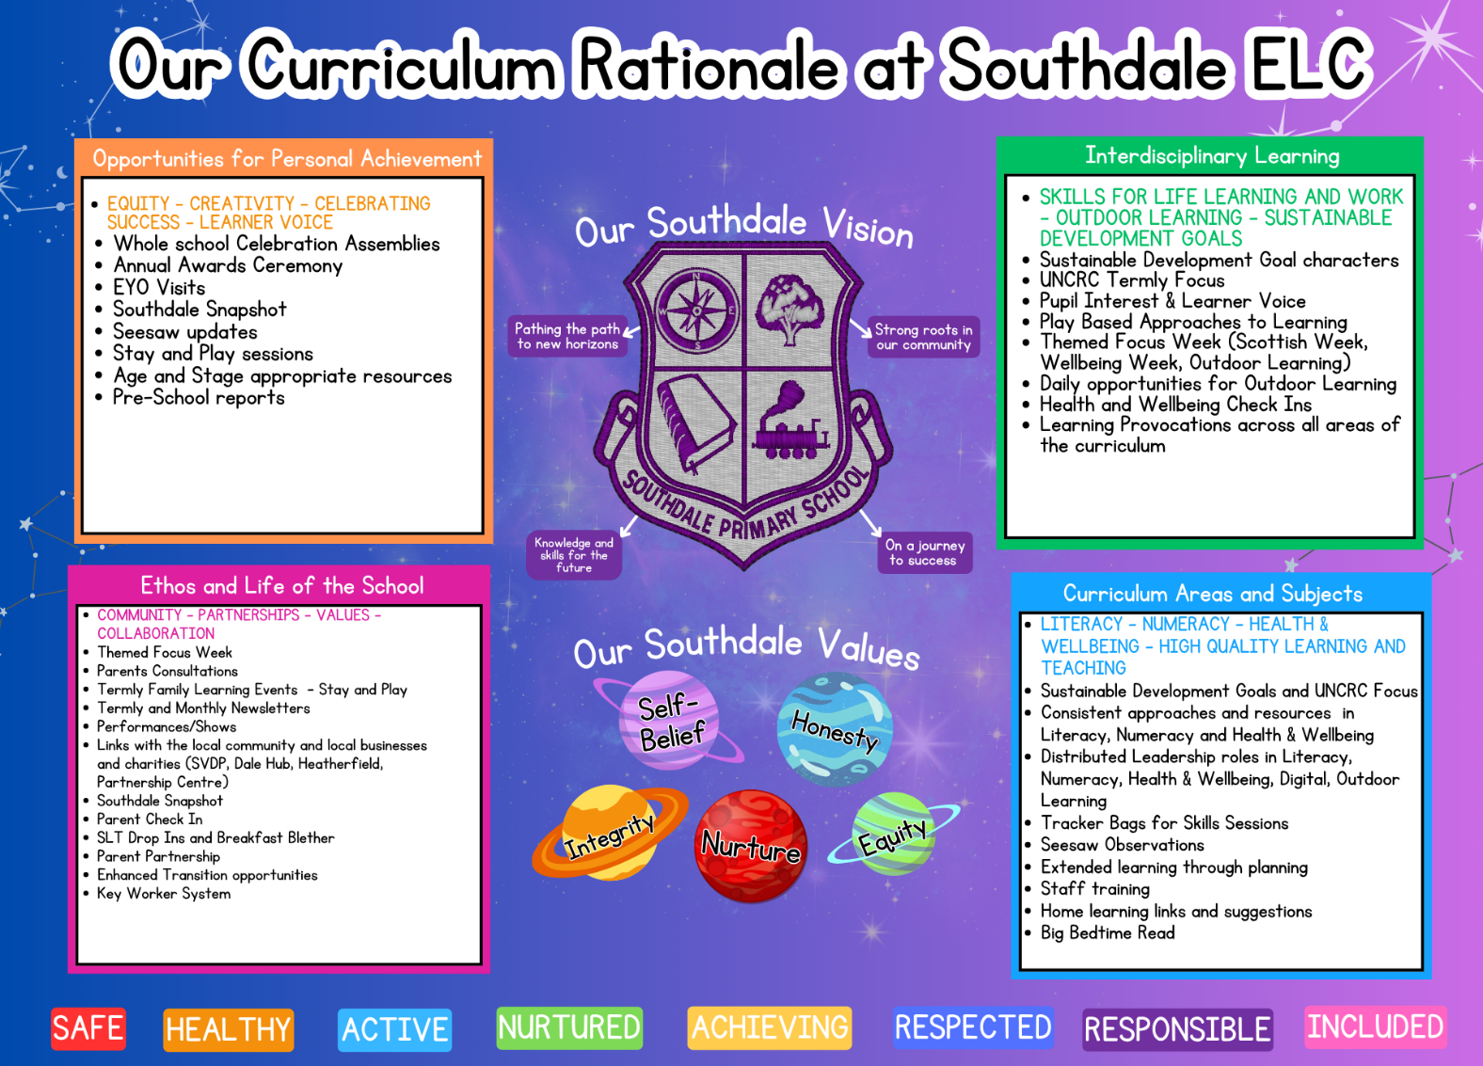

Southdale ELC Improvement Planning for Ensuring Excellence and Equity
ELC priorities linked to knowledge and data | Links to QIF ELC and HSCS | Proposed actions - | Timescale | Measures of Success
Meeting the needs of all children through inclusive and impactful pedagogy, with a particular focus on improvement in wellbeing:  All practitioners will enhance the quality of interactions to support equity in learning, with a clear focus on reducing the gender gap in engagement, participation and attainment. Through targeted professional learning and reflective practice, practitioners will demonstrate improved understanding and consistent application of high-quality interactions, evidenced through observations, self-evaluation and professional dialogue.  To embed a whole-setting commitment to health and wellbeing by ensuring that our vision, values, aims and curriculum framework consistently promote and support UNCRC, the physical, emotional and mental wellbeing of our children, families and staff, creating a nurturing, inclusive and positive learning community where everyone can thrive. | QIF ELC  2.3, 3.1, 3.2, 2.4, 1.2  HSCS  1, 2, 3, 4  QIF ELC  1.1, 1.2 2.3, 2.4, 3.1  HSCS  1, 2, 3, 4 | - EYO will attend 6 LOL sessions, 3 coaching meetings, a sharing event, and relevant CLPL to further develop knowledge and understanding of implementing targeted, high-quality interactions and inclusive learning experiences to increase engagement, participation and attainment for all children, with a focus on reducing the gender gap.  - EYO will support the Pedagogy Pioneer/s to further develop their knowledge and understanding of inclusive learning experiences and support them to apply this knowledge in their practice.  - EYO will work with HT and Pedagogy Pioneer/s to support the development of knowledge and understanding of inclusive learning experiences and the application of this e.g. through modelling, planning with colleagues, monitoring, quality assurance. ​  - Develop shared understanding of high-quality interactions and inclusive learning experiences and agreement of what this looks like in practice through agreed guidance and professional dialogue  - Integrate agreed strategies and approaches into daily routines and planning  - Best practice visits to be arranged with a focus on reducing the gender gap  - To review and refresh our values to ensure they clearly reflect a strong, shared commitment to health and wellbeing, in line with wellbeing indicators and UNCRC principles.  - To continue to promote a nurturing environment by establishing consistent, high-quality approaches to relationships, routines and interactions that ensure all children feel safe, respected and included, including Colour Monster  - To continue to strengthen family engagement by building effective partnerships and sharing strategies, information and resources to support children’s wellbeing at home and within the setting.  - Continue to use Seesaw and Southdale Snapshot to celebrate success  - Monthly newsletter to continue to feature a focus on UNCRC articles to promote understanding of children’s rights. | June 2027  September 2026 | Pre- during and post-professional learning self-evaluations practitioner confidence/knowledge ratings on inclusive learning experiences and on their abilities as a leader to improve practice in this area.  Evidence of intentional planning to develop inclusive learning experiences (e.g., in routines, spaces, interactions and experiences).  Tracking and observations show increased engagement, participation and attainment for all children, with a measurable reduction in the identified gender gap.  Monitoring activities (e.g. learning walks, observations, quality assurance) show that almost all staff consistently apply agreed nurturing approaches and strategies across daily interactions, routines and environments that support inclusive learning experiences.  Feedback from surveys, questionnaires or informal consultations shows that almost all families report feeling supported, informed and included in their child’s learning and wellbeing.  Planning documentation and floor books demonstrate clear and consistent inclusion of wellbeing experiences and outcomes, with regular evidence across all areas of the setting.
Improving achievement for all children through inclusive and impactful pedagogy, with a particular focus on Literacy and Numeracy (universal approaches):  All practitioners will enhance the quality of their interactions to actively challenge gender barriers and stereotypes to promote equity for all children.  The provision will ensure that all children have consistent access to carefully planned, high-quality indoor and outdoor learning experiences, with an emphasis on promoting literacy and numeracy through well-resourced, language- and number-rich environments.  Increased staff confidence in moderation practices will support greater consistency and reliability in professional judgements relating to children’s achievement in literacy and numeracy. | QIF ELC  2.3, 3.2, 3.3, 2.2, 3.1  HSCS  1, 2, 3, 4  QIF ELC  1.2, 1.1, 2.3, 3.2  HSCS  1, 3, 4  QIF ELC  2.3, 3.2, 1.2, 1.3  HSCS  3, 4 | - Use observations, tracking and assessment data to identify specific literacy gaps in engagement, participation and attainment between genders.  - Practitioners to continue to engage in professional learning to develop skills in modelling language, extending vocabulary, and engaging in sustained shared thinking during play.  - Audit and adapt the environment to ensure literacy opportunities reflect a wide range of interests and challenge gender stereotypes (e.g. mark-making in construction, storytelling in outdoor play).  - Continue to provide a range of books, stories and resources that challenge gender stereotypes and reflect a range of characters, roles and experiences.  - Continue to integrate meaningful literacy opportunities into all areas of play (indoors and outdoors), ensuring they are engaging and relevant for all children.  - Review indoor and outdoor spaces to ensure they are stimulating, accessible and well-resourced, providing high-quality opportunities for literacy and numeracy  - Continue to use responsive planning to deliver well-sequenced, meaningful learning experiences that promote literacy and numeracy across play  - Continue to develop high-quality interactions to extend language, thinking and numeracy skills through modelling, questioning and sustained shared thinking  - Continue to provide professional learning and collaborative moderation opportunities to develop staff confidence and ensure consistency in professional judgements in literacy and numeracy  - Staff will continue to engage in network meetings relevant to their curricular areas to strengthen practice and share expertise.  - Provide regular support and reflect sessions between the EYO and practitioners to continue to build confidence, strengthen practice and support progress in learning and teaching. | September  2026 | Children demonstrate a strong sense of belonging and inclusion, evidenced through observations and wellbeing assessments  Increased pupil voice and participation, with children regularly making choices and contributing to planning  Monitoring shows that indoor and outdoor spaces are consistently well-resourced and used effectively, with clear evidence of literacy and numeracy opportunities across all areas.  Positive feedback from families showing they feel their children are safe, respected and included  Observations and quality assurance show that almost all practitioners consistently use high-quality interactions, including modelling language, questioning and sustained shared thinking to extend learning.  Staff participation in moderation activities increases, with all practitioners demonstrating improved confidence and consistency in professional judgements, evidenced through moderation records, dialogue and shared assessments.
Tackling the attainment gap between the most and least disadvantaged children (targeted approaches):  Strengthened parental involvement through a planned programme of parent and carer engagement, increasing participation and providing targeted support for families affected by poverty.  Robust observation and effective analysis of assessment data will enable early identification of children’s needs, ensuring timely and appropriate support is implemented to reduce attainment gaps  Strong and effective partnerships will contribute positively to children’s progress in literacy, numeracy, and health and wellbeing. | QIF ELC  2.3, 3.2, 2.4, 1.1, 3.1  HSCS  1, 2, 3, 4  QIF ELC  2.7, 3.2, 3.1, 2.3  HSCS  1, 3, 4  QIF ELC  2.5, 2.7  HSCS  2, 4 | - Create and deliver a calendar of workshops, stay-and-play sessions and family events to support learning at home.  - Share guidance, resources and strategies (e.g. storytelling, play-based learning, high-quality interactions) to build confidence in supporting children’s learning.  - Continue to provide opportunities such as Big Bedtime Read, lending library or take-home packs to ensure all families have access to books and materials.  - Use a range of approaches (digital platforms, informal conversations, newsletters) to continue to build positive partnerships with families.  - Through E&E meetings, practitioners will regularly analyse assessment and tracking data to identify trends, inform planning and provide targeted support for individuals and groups.  - Engage effectively with multi-agency partners to provide coordinated support for children’s literacy, numeracy and wellbeing  - Signpost families to local libraries and community resources.  - Target support for families affected by poverty.  - Identify children and families requiring additional support.  - Continue to develop a targeted, nurturing approach for care experienced children by working closely with families and relevant professionals to provide consistent support, build secure relationships, and ensure individual needs are identified and met through personalised planning and regular review.  - Ensure Support for Learning (SfL) staff are actively involved in the ELC through collaboration with practitioners to identify children who are off track in their learning, and to develop, implement and review targeted support plans to promote progress. | August 2026 | Attendance records show that almost all of our families attend one or more workshops, stay-and-play sessions or family events across the year.  Feedback from questionnaires indicates that most of our families report increased confidence in supporting learning at home (e.g. storytelling, play, interactions).  Tracking of lending libraries, Big Bedtime Read and take-home packs shows regular uptake by most of our families, including targeted families, with increased frequency over time.  Ethos survey reports almost all families feel informed, included and supported  Records show that all identified children receive support, with regular review meetings in place, and tracking data demonstrates measurable improvement in targeted areas of literacy, numeracy and/or wellbeing
Meeting the needs of all children through inclusive and impactful pedagogy, with a particular focus on curriculum making  Embedding children’s voice within the Curriculum Improvement Cycle will strengthen learner participation and leadership, supporting the development of meaningful, relevant, and engaging learning experiences.  Children will access a wide range of high-quality learning environments and experiences, including outdoor learning, play-based approaches, and the use of digital technologies, to support engagement, creativity, and overall development.  Effective partnerships with families and the wider community will enhance children’s development of transferable skills for life and learning, while promoting their participation in decision-making within their own learning experiences. | QIF ELC  2.2, 2.3, 2.4, 3.3, 3.1  HSCS  1, 2, 3, 4  QIF ELC  2.3, 2.2. 3.3. 3.2, 3.1  HSCS  1, 2, 3, 4  QIF ELC  2.7, 2.2, 3.3, 3.2, 3.1  HSCS  1, 2, 3, 4 | - Ensure consistent approaches to gather and record children’s ideas, interests and views  - Continue to use children’s interests and feedback to inform responsive planning and the Curriculum Improvement Cycle, ensuring learning is relevant and engaging  - Continue to provide regular opportunities for children to make choices, lead play and contribute to decisions about their learning  - Through professional learning and dialogue, continue to support staff to effectively listen to, interpret and act on children’s voice within daily practice  - Use observations, learning walks and professional discussion to ensure children’s voice is clearly influencing planning, experiences and outcomes  - Review Curriculum Rationale to ensure a shared understanding of how our curriculum supports play, outdoor learning, creativity and digital skills, reflecting children’s needs and context.  - Build local links and plan real-life experiences (visits, visitors, local environment) to enrich the curriculum.  - Staff will continue to engage in best practice visits, network meetings, and up-to-date research and professional reading to strengthen knowledge and inform the ongoing development of the curriculum.  - A structured quality assurance calendar and ongoing staff CLPL will ensure effective implementation and sustainability of CIC developments. | January  2027 | Monitoring shows all practitioners consistently gather and record children’s views using agreed approaches.  Planning clearly reflects children’s interests and feedback across all groups on a regular basis.  Observations show almost all children regularly make choices, lead play and influence decisions.  Staff demonstrate confidence in responding to children’s voice through practice and professional dialogue.  Quality assurance shows children’s voice is embedded in planning, environments and experiences.

